**Service training**

Day 7

* Set-up a side station
* change ashtrays
* Present toothpicks
* Handle take away items
* settling bill
* Handle payment

Set up a side station

设置工作台

Standard:

标准：

* All side stations must be fully set at least 15 minutes prior to the service period. All side stations must be fully stocked at the opening and maintained during the service period and cleaned at the end of the shift.

所有的工作台都必须在开餐前十五分钟准备好，保证开餐期间各种物品的供应，营业时间结束时应把工作台打扫干净。

Procedures:

程序：

Items which may be kept at a side stand are: Chinaware & flatware, ashtrays, condiments, coffee & tea cups, saucers, matches, salt and pepper shakers, tray jack, cutlery chopsticks.

工作台应备物品：瓷器、不锈钢餐具，烟灰缸、调味品、咖啡杯或茶杯、垫盘、火柴、盐和胡椒瓶，筷子、托盘架。

Special attention should be given to the condiments stored at the service station. Ensure all salt & pepper, toothpick containers are full at all times.

应特别注意在落台存放的调味品，常把盐、胡椒及牙签罐装满。

Notes:

注意：

* Never place any soiled plate or cutlery inside service station.

不要把脏的餐具放进备餐台内。

* Jack stands are not to be used as side stations.

不得把托盘展示架当做落台使用。

* Personal items cannot be stored in the side stations.

服务柜内不可存放私人物品、清洁用品。

* The side stations must be cleaned periodically.

服务柜应定期清洁。

|  |  |  |
| --- | --- | --- |
|  |  |  |

The side station is also called the dummy waiter or service console. This is a very important piece of furniture in a restaurant. It is used by the service staff for keeping all the service equipment at one place. It is also used as a landing table for the dishes picked up from the kitchen on the way to the table and the dirty dishes from the guest's table to the wash-up area. For the convenience of the service staff, the side station should be strategically located in a restaurant. The side station should be kept clean and presentable as it can be seen by the guests.

这服务柜也被称为虚拟服务员或服务控制台。这是一个非常重要的餐厅家具。它是用来让服务人员保持所有服务设备都在同一个地方。它也被用来作为从厨房送菜的盘子和需要清洁的脏盘子的交叉点。为方便服务人员，服务柜应有策略地设置在餐厅里。应常保持清洁和良好，因为这服务柜客人会可以看得到。

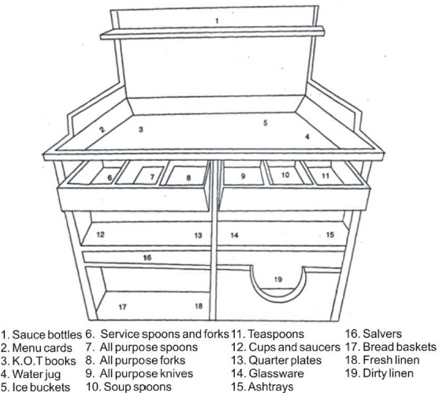

Change ashtrays

更换烟灰缸

Standard:

标准：

* Check ashtrays frequently, and remove as necessary replacing with clean ones.

经常检查烟灰缸，必要时更换一个干净的。

* Change ashtray if there is more than two cigarette buds inside or any other garbage.

如果有两个以上的卷烟芽内或任何其他垃圾，立刻更换烟灰缸。

Procedures:

程序：

* + - 1. Carry clean ashtrays to the table on a tray

用托盘端干净的烟灰缸

* + - 1. Use the capping method by placing the clean ashtray on top of the dirty one.

使用封盖方法把干净的烟灰缸放在脏的顶部。

1. Remove from the table and place the dirty ashtray on side tray.

从桌上拿走脏的烟灰缸，并放置一边托盘上。

* make sure that used ashtrays are completely covered before removing them from the table and that no ash floats onto the table or crockery

确保使用的烟灰缸是从桌上移走之前完全被覆盖并没有灰留在桌子上。

1. Place clean ashtray back on table.

重新放干净的烟灰缸在桌子上。

* Make sure the replaced ashtray is spotless, clean and not broken

确保更换的烟灰缸是一尘不染，干净，不破

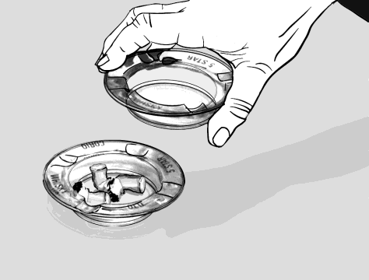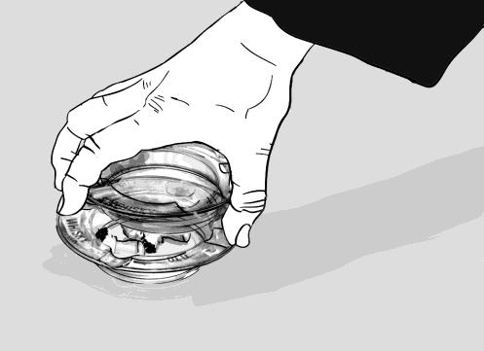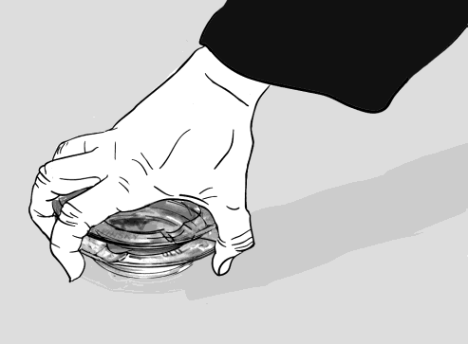

Present toothpicks

奉上牙签

Standard:

标准：

* Toothpicks must always be presented in the toothpicks holder or small plate with a napkin.

每次牙签必须用牙签筒奉上或以餐巾纸附上。

Procedures:

程序：

* Present one holder onto the centre of the table after the guests finished their meals

客人用餐后，应把牙签筒放到餐桌的中心。

Handle take-away items

处理外带食物

Procedures:

程序：

When a customer requests their food to be packed to take away:

当客户请求他们的食品包装带走:

Ensure which items your guest desires to be packed

确定客人要求带走的食品

Return the plate to the kitchen area where packing is done, communicate with the kitchen staff to include the specific items in the box/bag

返回厨房处理包装外带食物，跟厨房员工沟通放好特定食品在盒子里

Add correspondent plastic cutlery and paper napkins in the bag

放相应的塑料餐具跟餐巾纸到盒子里

Deliver to the guests and watch their reaction when introducing the bag, see if the guest would like to receive it

送到客人面前并提示盒子里的外带，观察客人的反应和是否还要外带。

The customer may say

客人可能会说

* We’d like this to takeaway please.

我们想请你帮我们把这个打包。

* Can we get this to takeaway please?

我们可以把这个打包带走吗？

Settling bill

买单服务

Standard:

标准：

* Guest will be presented with a bill/check prior to their departure from the restaurant.

服务员应在客人离开之前送上帐单。

* All charges for Food & Beverage guests which have incurred in the Restaurant will be accurately entered into the MICROS Point of Sale terminal.

客人的所有餐饮帐目均应键入MICROS电脑系统。

* Guest check present only upon guest’s request.

只有在客人要求账单时才能给账单

Procedures:

程序：

At the completion of the service, the service personnel will ask if the guest would like any additional food or beverage items.

服务结束后，应询问客人是否需要其它食品。

If the guest requests the bill/check, the bill will be checked for accuracy before presenting it in a bill folder.

当客人要结帐时，应先确认帐目是否正确才放入帐单夹。

Check the bill folder and ensure it is clean and all promotional materials are in the proper place.

检查帐单夹是否干净，并将宣传单正确地放入帐单夹。

Close the billfold when we presented the guest check to the person who asks for bill. “Excuse me, Mr. Wang. Your bill.”

合上帐单夹给要账单的客人“你好，王先生，您的账单。”

* The bill folder should be presented with two hands.

应双手将帐单夹递给客人。

1. When the guest has placed their credit card, cash or signed, we begin the settlement for the guest check, according to the finance guideline.

当客人把信用卡，现金或签单放在收账簿里后，按照财务指引进行结算

1. All the change is returned to the guest in a guest check folder and is never assumed to be gratuity.

所找的钱要还给顾客，不要假设是小费

1. Return the credit card and properly imprinted voucher in a guest check folder and remind the guest not to forget the credit card. Use the guest’s name here; it’s on the credit card.

把卡还给客人，并让客人在收据上签名，提醒客人不要忘了拿卡。（称呼客人的名字，因为客人的名字写在信用卡上）

1. In case of the guest ask for “Fa Piao”. Process to the cashier counter and get exact bill amount of “Fa Piao”.

如客人需要发票（个人或公司），到收银台处领取适额发票。

1. Present to the guest with the “Fa Piao” in a bill folder.

将发票放到帐单夹中呈交客人。

1. All the guests are thanked, using their name, when the settlement is complete.

在结账完后，使用客人的名字，向他们表示感谢

Settling the Bill

结帐

Many customers use the Chinese “买单” when asking to pay, or simply make a writing motion in the air. Otherwise you will hear either the English term ‘bill, or the American term ‘check’.

结帐时许多客人会用汉语说 “买单” 或是在空中比划写字的动作，否则你会听到英式英语中的 “bill” 或美式英语中的 “check” 。

* Can I please have the bill?

请买单。

* Check, please.

请买单。

The customer may say

客人可能会说

* Please give me a receipt.

请给我发票。

* We would like to pay separately.

我们想分开付。

Paying by credit card

信用卡结帐

**Guest:** Do you take credit cards?

你们接受信用卡付帐吗?

* Yes, we accept all major cards.

我们接受所有的国际及银联信用卡。

* Please enter your pin number.

请输入您的密码.

* Please sign here.

请在此签名.

Problems when paying by card

处理信用卡结帐时可能出现的问题

If there is a problem with a customer’s card and it does not work, it is very important that you only approach the customer who gave you the card and politely and quietly explain the situation.

如遇到客人信用卡刷不了，靠近卡主本人并礼貌，轻声地解释问题原因。

* I’m very sorry; our machine isn’t accepting this card. Do you have another one you would like to try?

非常抱歉，信用卡机没有接受这张卡，您还有别的卡吗？

Foreign currency

外币

Although in China we only accept RMB as a cash payment, so if a customer gives you foreign currency you must inform your manager immediately

如果客人用外币，第一时间告诉经理。

* Sorry, just moment. I will get my manager now.

对不起，我马上叫我们经理过来。

* Do you have some RMB, or perhaps a credit card?

您有人民币或信用卡吗？

Problems with the bill

处理帐单问题

If a customer has a complaint about the bill, always listen carefully, find out what the problem is and look into it right away. If a mistake has been made, apologize to the customer and try to resolve the problem as quickly as possible.

如顾客对帐单提出异意，要认真倾听，找出问题并马上处理。如果有错误要向顾客道歉并尽快努力解决。

* I think there is a mistake with the bill.

帐单有一些错误。

* This is not our bill.

这不是我们的帐单。

* I didn’t order this.

我没点这个。

* We cancelled this dish.

我们取消了这道菜。

* This dish didn’t come.

这道菜没上。

* I only had one…

我只点了一个…

**Guest:** Can you please explain these extra charges?

请告诉我这些额外收费是什么？

* That is for your…

那是你的…

**Guest:**I think you have over-charged me.

你多收我钱了吧？

**Guest:** I think you have under-charged me.

你少收我钱了吧？

* Let me check that for you right away.

让我马上查对一下。

* I’m very sorry for the mistake.

真抱歉, 是我们弄错了。

If you forget to charge the customer for something

忘记收某样东西的钱

If you discover an item has been left off a customer’s bill after they have paid, you should first apologize and politely explain what has happened.

当发现客人结帐后有一样东西没有收钱，首先要道歉然后礼貌地解释清楚。

* I’m extremely sorry; we have made a mistake with your bill.

非常道歉，帐单我们弄错了。

* We forgot to add…

忘记加…

Handle payments

付款处理

Standard:

标准：

* All guest accounts shall be settled prior to the guest’s departure from the outlet

所有客人的帐单要在客人离开前准备好。

Procedures:

程序：

Guests may settle their account in the outlet in any of the following methods:

客人可使用以下方式结帐：

**Cash Payment**

现金

1. Ensure cash given is correct enough to cover the amount on the bill.

确保现金数目正确。

1. Take it to the cashier.

如数拿给收银。

1. Return the change with the first copy of the bill to the guest in a bill folder.

用帐单夹把零钱及第一联帐单返给客人。

1. Leave the folder closed on the table and say “This is your change sir/madam, thank you very much.”

展示帐单并感谢客人。“ 这是您的零钱，请收好，先生 /女士”

* Do not wait at the table for tips.

不要等在桌旁要小费。

**Credit Card**

信用卡

1. Present bill and guest presents credit card.

给客人看帐单，从客人处取信用卡。

1. Bring it back to the cashier.

交帐单及信用卡给收银员。

1. Cashier will process the credit card and slip after approval is obtained. Check the slip to see the amount is correct.

收银划卡，出收款单并检查数目是否准确。

1. Present to guest with the card, slip and bill for signature.

把帐单拿给客人签名。

1. Check the signature on the card.

检查卡上签名是否正确。

1. Return the credit card to guest, together with the cardholder sales slip and the first copy of the bill.

把卡 (身份证 ) 和存根返给客人。

1. Present the above in the folder, open it and say, “Thank you very much sir/madam.

打开出示给客人并说 “ 非常感谢，先生 /女士 ”

1. Leave the folder on the table and don't wait for tips.

不要等在桌旁要小费。

NB: No copies of guest bills/checks should be destroyed, even if they have been re-printed.

注：任何帐单均不可撕毁，包括重新打印及作废的帐单。